Ideation Phase
Brainstorm & Idea Prioritization Template
Date | 22 September 2026
Team ID | [Enter Team ID]
Project Name | Streamlining IT Procurement: Automating Standard Laptop Orders with Flow Designer
Maximum Marks | 4 Marks

This ideation exercise applies the standard Brainstorm & Idea Prioritization method to the IT Procurement problem below. The team generated a wide set of ideas individually, grouped related ideas into themes, and prioritized the themes by importance and feasibility to select the direction for this project.

Step 1: Team Gathering, Collaboration & Selecting the Problem Statement
Team Gathering:
Participant | Role in this Ideation Session
Team Member 1 | IT Procurement Lead (Facilitator)
Team Member 2 | ServiceNow Developer – Flow Designer
Team Member 3 | Business Analyst
Team Member 4 | Hardware / Support Team Representative
Team Member 5 | End-User Representative

Problem Statement:
PROBLEM STATEMENT (How Might We)
How might we streamline the standard laptop procurement process so that hardware configuration tasks are generated and assigned automatically — reducing delays, manual overhead, and user wait times?

Key Rules of Brainstorming Followed:
- Stay focused on the problem statement
- Welcome bold, unconventional ideas
- Hold off judging ideas during the session
- Build on each other's ideas
- Aim for quantity first, quality later
- Use notes / visuals wherever possible

Step 2: Brainstorm — Idea Listing
Each team member individually noted down ideas addressing the problem statement before the group discussion:
Team Member 1 | Team Member 2 | Team Member 3 | Team Member 4 | Team Member 5
1. Auto-create a hardware configuration task in Flow Designer the moment a laptop request is approved. | 2. Route manager approval automatically based on the requester's cost centre / reporting hierarchy. | 3. Build a guided self-service catalog item that auto-fills department and manager details. | 4. Maintain a small buffer stock of standard laptops for the most common roles. | 5. Auto-register the asset in the CMDB once the Hardware team closes the task.
6. Auto-assign the task to the Hardware team based on the requester's location / branch. | 7. Auto-approve repeat or standard requests that fall under a pre-set cost threshold. | 8. Add a Virtual Agent / chatbot so employees can check request status anytime. | 9. Integrate with the vendor's API for real-time stock levels and delivery ETA. | 10. Build an IT dashboard showing all pending / in-progress laptop requests at a glance.
11. Add an SLA timer that escalates the task if configuration hasn't started within 4 hours. | 12. Skip the approval step for a simple replacement of an existing employee's laptop. | 13. Auto-notify the employee by email once the laptop is configured and ready for pickup. | 14. Use an RPA bot to auto-raise a purchase order when stock falls below threshold. | 15. Send a short feedback survey to the employee after laptop delivery.

Step 2 (contd.): Grouping Ideas into Themes
Similar ideas were clustered together and given a theme label, as shown below:
Cluster A — Flow Automation (Request → Task → Fulfilment)
- Auto-create a hardware configuration task in Flow Designer the moment a laptop request is approved.
- Auto-assign the task to the Hardware team based on the requester's location / branch.
- Add an SLA timer that escalates the task if configuration hasn't started within 4 hours.
- Auto-register the asset in the CMDB once the Hardware team closes the task.
Cluster B — Smart Approval Routing
- Route manager approval automatically based on the requester's cost centre / reporting hierarchy.
- Auto-approve repeat or standard requests that fall under a pre-set cost threshold.
- Skip the approval step for a simple replacement of an existing employee's laptop.
Cluster C — Self-Service, Communication & Feedback
- Build a guided self-service catalog item that auto-fills department and manager details.
- Add a Virtual Agent / chatbot so employees can check request status anytime.
- Auto-notify the employee by email once the laptop is configured and ready for pickup.
- Build an IT dashboard showing all pending / in-progress laptop requests at a glance.
- Send a short feedback survey to the employee after laptop delivery.
Cluster D — Inventory & Vendor Readiness
- Maintain a small buffer stock of standard laptops for the most common roles.
- Integrate with the vendor's API for real-time stock levels and delivery ETA.
- Use an RPA bot to auto-raise a purchase order when stock falls below threshold.

Step 3: Idea Prioritization (Importance vs. Feasibility)
The four themes were plotted on an Importance-vs-Feasibility grid to decide what to build first:
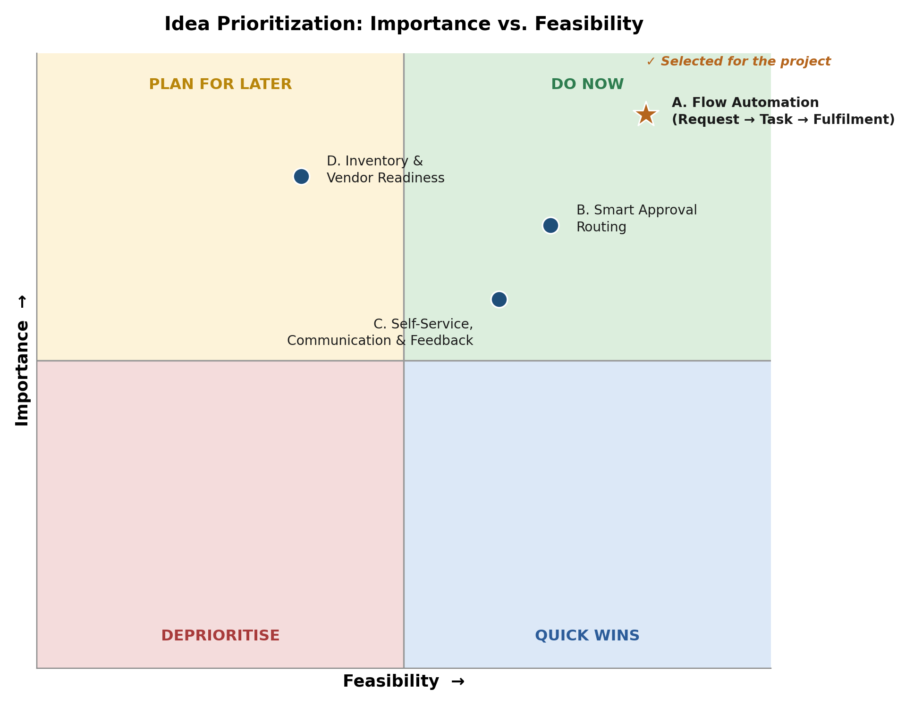
Outcome:
Cluster A – Flow Automation (Request → Task → Fulfilment) scored highest on both importance and feasibility. It directly matches the project's problem statement and user story — automatically generating and assigning a hardware configuration task the moment a standard laptop request is approved — so it was selected as the idea to build in this project via ServiceNow Flow Designer. Clusters B, C and D remain documented as potential Phase-2 enhancements once the core automation is live.

